All entries to be sent to:
Rhona Lawrence, Secretary SCOTDANCE,
14 Eider Road, Newburgh, Ellon. AB41 6FD

to arrive by Friday 16th August 2019
Email: scotdancechampionship@btinternet.com

Standard Entry Fees £20 per competitor.
No entry will be accepted without a Registration number.
Late entries may be accepted up to Wednesday 21st August 2019 at DOUBLE the Entry Fees.
Make Cheques and Postal Orders payable to SCOTDANCE. No Dance Mats allowed.
Overseas competitors must remit in Sterling.
Personal cheques must be drawn on a British Bank
Please enclose a large stamped addressed envelope for your entry confirmation and competitor number. Overseas competitors should provide an address in the United Kingdom for receipt of competitor numbers to avoid the possibility of items going missing in the post. Alternatively numbers can be picked up before the competition commences.
IMPORTANT: No competitor will be permitted to dance out of number order. Dancers in the first set of a Reel will be required to 'fill-in' at the end of the class if necessary due to uneven numbers. Last to enter will be first to dance.

On-Line entries now open at – www.grampianfestivals.com

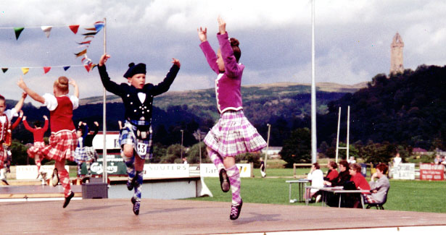



presents the

50th COMMONWEALTH
HIGHLAND DANCE CHAMPIONSHIPS
(SOBHD Reg No. CH1)

Sunday 25th August 2019
Commencing 8.45 am
(Doors open 8.00 am)

Venue
Albert Halls
Dumbarton Road
Stirling
FK8 2QL

In association with
United Kingdom Alliance
Billy Forsyth Scottish Dancing Shoes

MORNING SESSION

Prizes Six medals in each event Six Championship Trophies in each section

Section 1
Commonwealth Championship 7 and under 9 Years

Section 2
Commonwealth Championship 9 years

Section 3
Commonwealth Championship 10 years

Section 4
Commonwealth Championship 11 years

Section 5
Commonwealth Championship 12 years

Section 6
Commonwealth Championship 13 years

Sections 1 to 6 will commence at 8.45am with Prizes awarded on completion

AFTERNOON SESSION

Section 7
Commonwealth Championship 14 years

Section 8
Commonwealth Championship 15 years

Sections 7 and 8 Six medals in each event
Six Championship Trophies in each section

Section 9
Commonwealth Championship 16 and under 18 years

Prizes Cash prizes 1st – 6th places Six Championship Trophies

Section 10
Commonwealth Championship Adult 18 years and over

Prizes Cash prizes 1st – 6th places Six Championship Trophies

Sections 7 to 10 will commence after Morning Session Prize Giving
(approx. 1.00 pm)

Prizes for Sections 7 to 10 awarded on completion

The William McNiven Cuthbertson Trophy will be awarded to
The Dancer with the most Championship points over Sections 1 to 10

All sections will dance the four Championship Dances
using the steps laid down by SOBHD for 2019 Championships

--------------------------------------------------------------------------------------------

2019 COMMONWEALTH CHAMPIONSHIP - ENTRY FORM

Name ……………………………………………………………………… .. M / F
Registration No ………………… Date of Birth ……………… Age on 25 Aug ’19 …….
Address ……………………………………………………………………………………..
…………………………………………… Tel. …………………………..…
Email address …………………………………………… ……………………………..
Dance School ……………………………………………………………………………….
Address ……………………………………………………………………………………..
Entry Section ………………………… Entry Fee Enclosed ………..……

I understand that this competition is held under the rules and regulations of the
Scottish Official Board of Highland Dancing and agree to be bound by them.

Signed ………………………………………………………………………………………
Parent/Teacher/Competitor (over 16 yrs)

